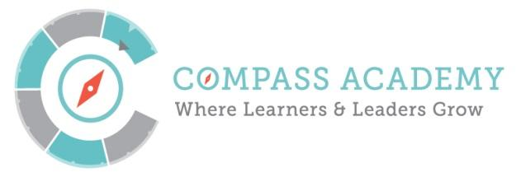
Board Meeting Agenda
City Year Denver Office
789 Sherman St #400
December 17th, 2015 4:30 – 6:30PM

(Next meeting is January 21st 4:30 – 6:30PM)

Conference Call-In Number:
712-775-7031 ID: 754-993-808

Time | Title and Description | Action
4:30–4:40PM  10 minutes | Ripples and Joys  Public Comment | Participate
4:40-4:45PM  5 minutes | Minutes – Mary  Monthly Financials – Jason and Ken | Review  Approve
4:45–5:00PM  15 minutes | ED Update | Inform  Discuss
5:00-5:30PM  30 minutes | Committee Updates:  - Executive  - Finance  - Academic Performance | Inform
5:30-6:10PM  40 minutes | Board Nomination Process and Trustee Terms  - Review and Approve Nomination process  - Discuss timeline to change the Compass By-laws to accommodate new Board members  - Vote on Board terms and renewal process | Review  Approve
6:10-6:15PM | Closing – Mary Seawell
6:15PM | Standing Executive Session – As needed

Attached Documents:
- Compass Finances as of 11/31/15
- Compass Financial Metrics
- Board Member Nomination Process Memo
- Board Member Nomination Process
- Board Member Nomination Policy
- Bylaws change memo
- Compass Governing Board Terms and Classifications

