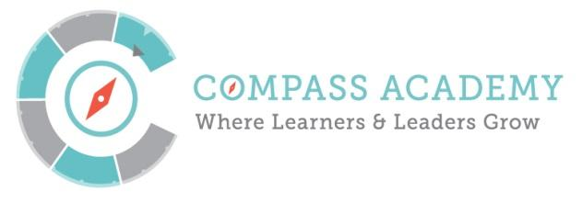
Board Meeting Agenda
City Year Denver Office
789 Sherman St #400, Denver, CO 80203

November 19th, 2015 4:30 – 6:30PM

(Next meeting is December 17th 4:30 – 6:30PM)

Conference Call-In Number:
712-775-7031 ID: 754-993-808

Time | Title and Description | Action
4:30–4:35PM  5 minutes | Ripples and Joys  Public Comment | Participate
4:35-4:40PM  5 minutes | Minutes – Mary | Review  Approve
4:40–5:20PM  40 minutes | ED Update  - Student Recruitment  - Dept. of Justice visit  - Staff Hiring  - Facilities update  - Holiday staff appreciation planning | Inform  Discuss
5:20-5:40PM  20 minutes | Committee Updates:  - Finance - Chair: Ken  - Jason: Financial Update | Inform
5:40-6:00PM  20 minutes | Board Nomination Process  - Review and Approve Nomination process  - Update Board Matrix  - Discuss change in Compass By-laws to accommodate new Board members | Review  Approve
6:00pm | Closing and Adjournment – Mary Seawell

6:00-6:05pm | Break

6:05-6:35  30 minutes | Academic Performance Committee Session:  Bob, Jeff, Annie, Mike, Steph, Jim  - Review goals and guiding principles for the committee from Bylaws  - Review proposed meeting schedule  - Overview of current student diagnostics and discuss the creation of a performance dashboard | Discuss  Review

Attached Documents:
- Year to Date Financials as of October 31, 2015
- Board Nomination Memo
- Board Nomination Process
- Board Nomination Policy
- Board Matrix (to be updated at meeting with terms noted)
- By-law change procedure Memo
- Goals and Principles for the Academic Performance Committee

