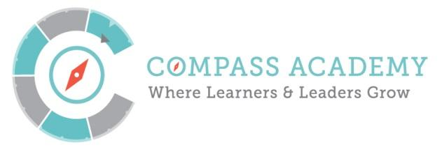
Board Meeting Agenda
City Year Denver Office
789 Sherman St #400
January 21st, 2016 4:30 – 6:30PM MT

(Next meeting is February 18th 4:30 – 6:30PM)

Conference Call-In Number:
712-775-7031 ID: 754-993-808

Time | Title and Description | Action
4:30–4:40PM  10 minutes | Ripples and Joys  Public Comment | Participate
4:40-4:45PM  5 minutes | Minutes – Mary  Monthly Financials and Spring Budget – Jason and Ken | Review  Approve
4:45–5:10PM  25 minutes | ED Update – Marcia Fulton | Inform  Discuss
5:10-5:40PM  30 minutes | Standing Committee Updates :  Chairs may pass if there are no material updates  - Executive  - Finance  - Academic Performance | Inform
5:40-5:55PM  20 minutes | Bylaw Amendments  - Review changes to Board Bylaws  - Vote to approve | Review  Approve
5:55-6:00PM | Closing – Mary Seawell
End of Governing Board Meeting
6:05-6:30PM  25 minutes | Academic Committee Session  Discuss process for review and approval of the Compass Accountability Plan | Discuss

Attached Documents:
- Compass Finances as of 12/31/15 and Compass Spring Budget
- Board Minutes from 12/17/15
- Bylaw Revision Overview Memo
- Revised Board Bylaws
- Draft Accountability Plan (for discussion by the Academic Committee)

